8/2/2024

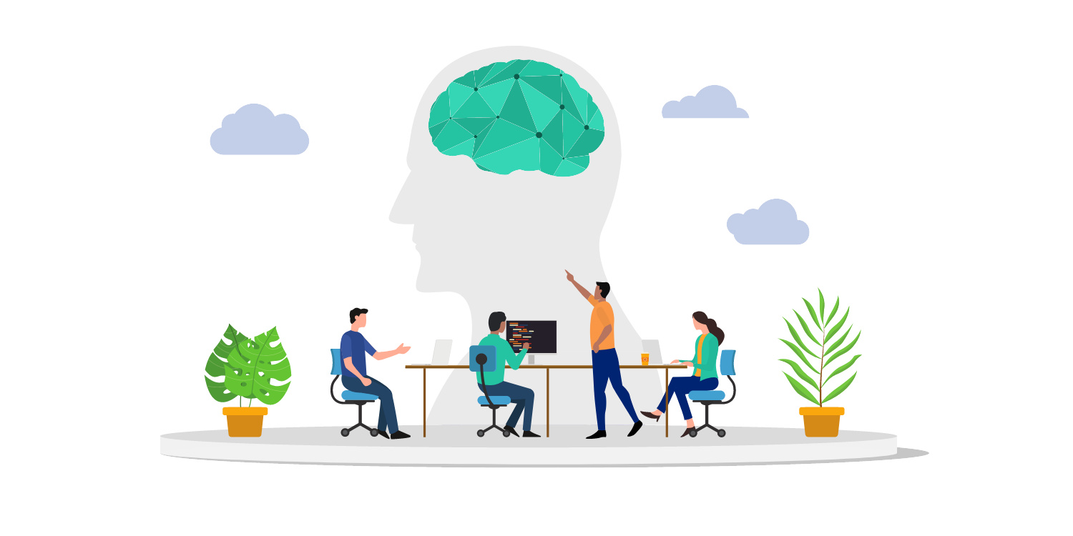

**Knowledge Test**

**TIDKE ASHOK TATERAO**

nsti cALICUT

**Knowledge Test**

**AIM:**

Implement various deep learning tasks using Keras and TensorFlow, including building a neural network, data augmentation, custom loss functions, and transfer learning.

**Requirements:**

* Pc/Laptop
* VS Code
* Chrome
* Python installed with required libraries (Keras, TensorFlow, numpy, matplotlib)

**Learning Outcome:**

Apply and understand the steps involved in building neural networks, augmenting data, implementing custom loss functions, and using transfer learning for image classification tasks.

**Procedure:**

**1.** **Building a Simple Neural Network**

**Step-1: Import necessary packages**

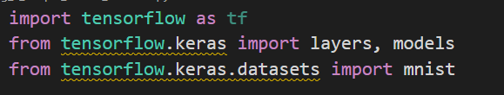

**Step-2: Load and preprocess the MNIST dataset**

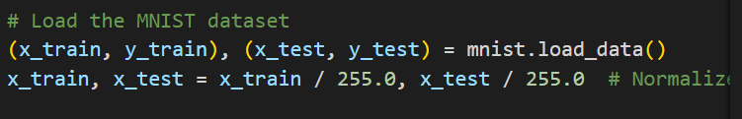

**Step-3: Build the neural network model**

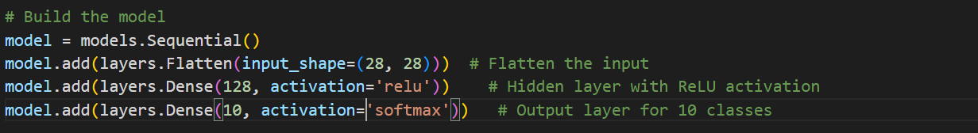

**Step-4: Compile and train the model**

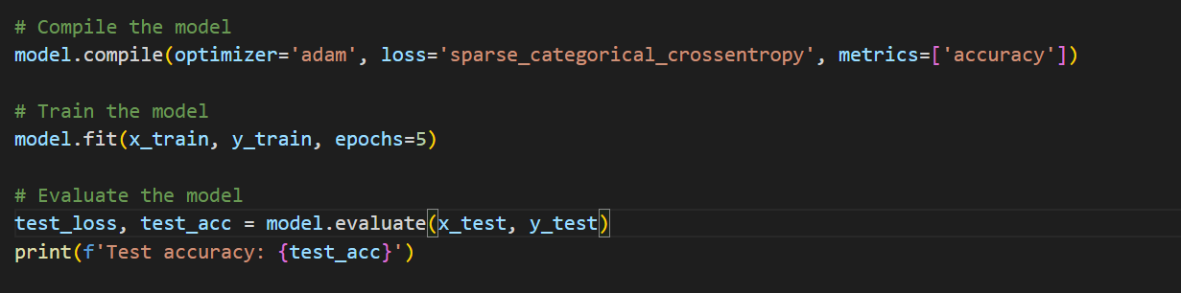

**Output:**

* Trained neural network on MNIST dataset with training and validation accuracy.

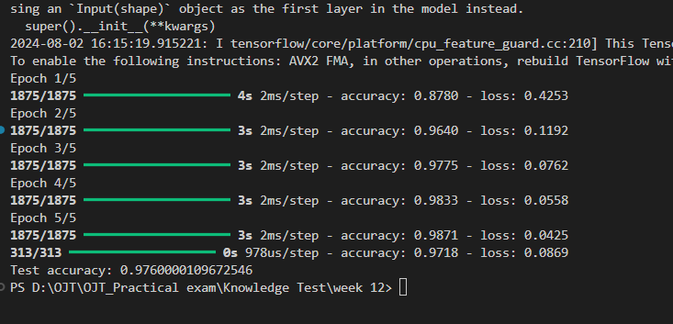

**2.** **Data Augmentation**

**Step-1: Import necessary packages for augmentation**

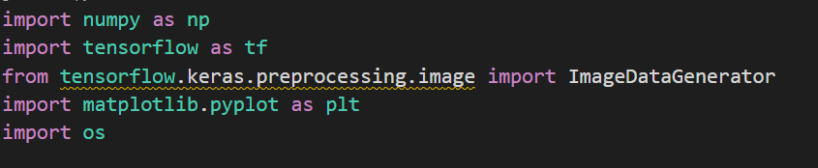

**Step-2:** **Define the path to your image**



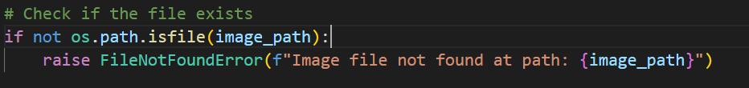

**Step-3:** **Create an instance of ImageDataGenerator with multiple augmentation techniques**

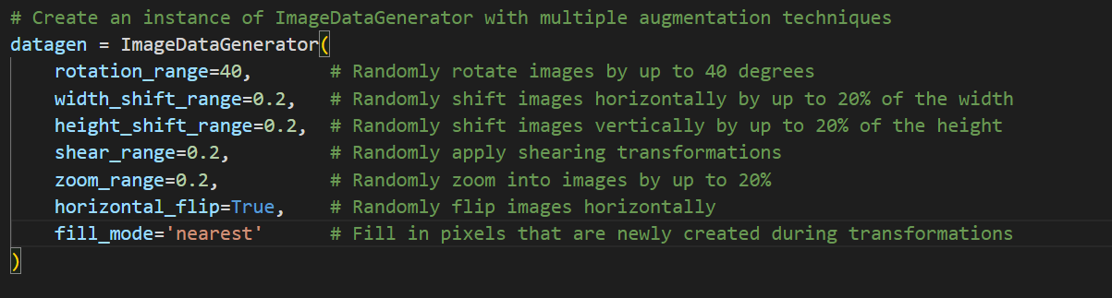

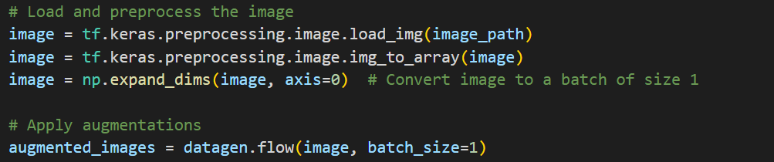

**Step-4:plot for image**

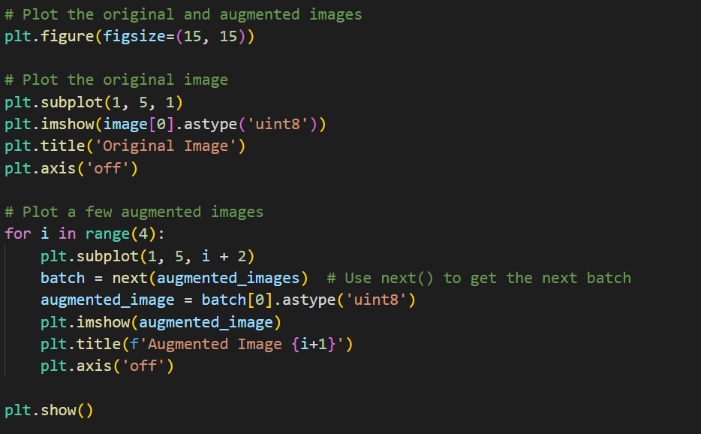

**Output:**

* Augmented images demonstrating various augmentation techniques.

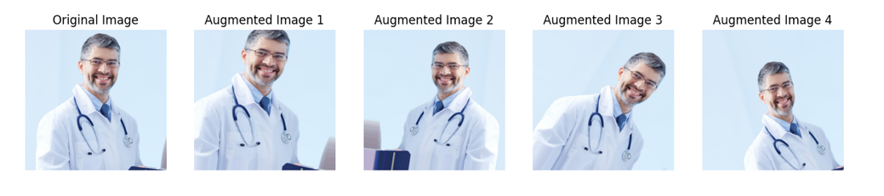

**3.** **Custom Loss Function**

**Step-1: Define the custom loss function**

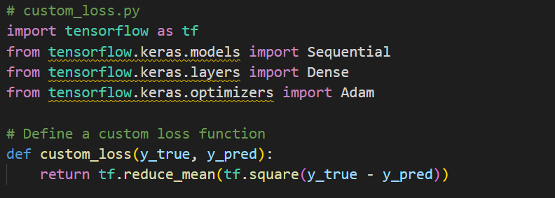

**Step-2: Build a simple model using the custom loss function**

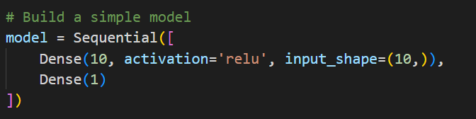

**Step-3: saved the model**

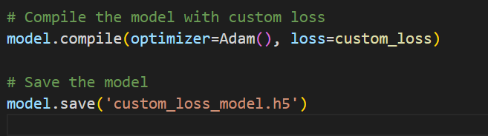

**Output:**

* Simple model using custom loss function with Mean Absolute Error (MAE) as a metric.

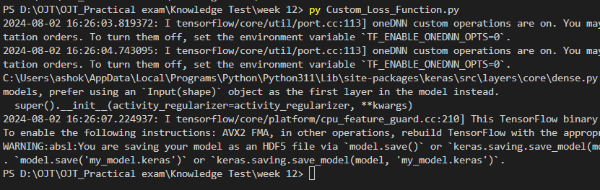

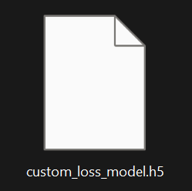

**4.** **Transfer Learning:**

**Step-1: Imported nececary libraries**

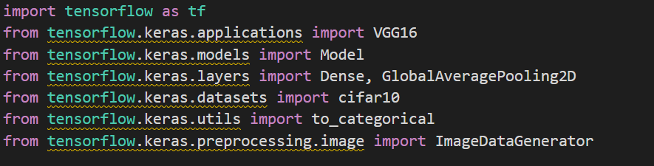

**Step-2: Load and Preprocess CIFAR-10 Dataset**

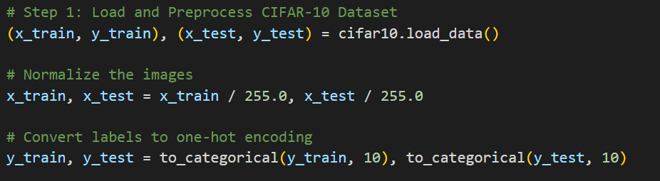

**Step-3: Create ImageDataGenerators for training and testing**

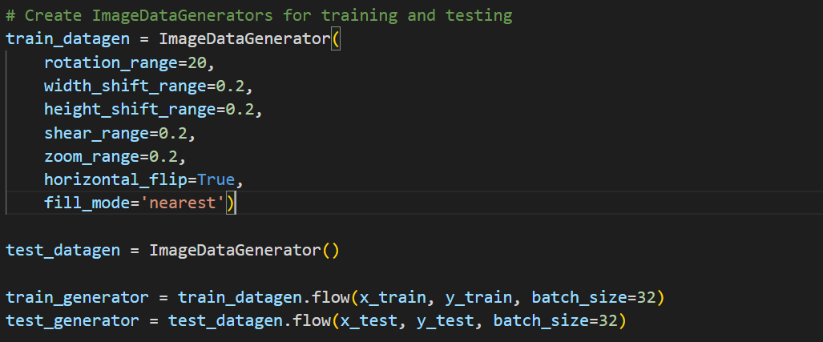

**Step-4: Load and Prepare the Pre-trained VGG16 Model**

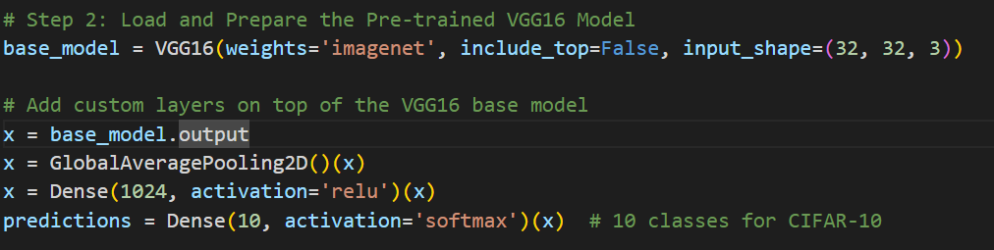

**Step-5: Define the complete model**

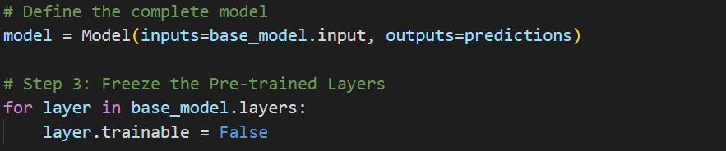

**Step-6: Compile the model**

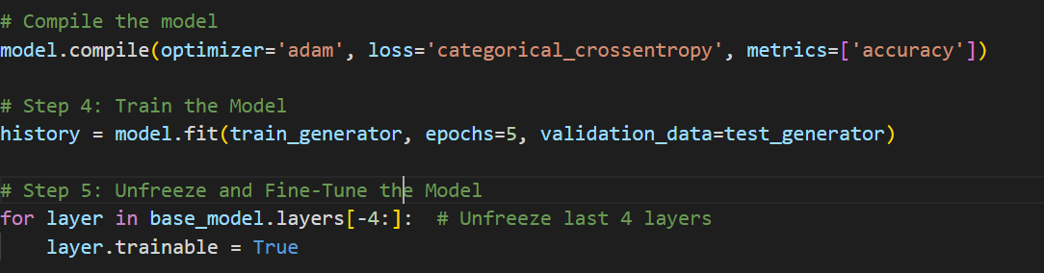

**Step-6: Recompile the model with a lower learning rate**

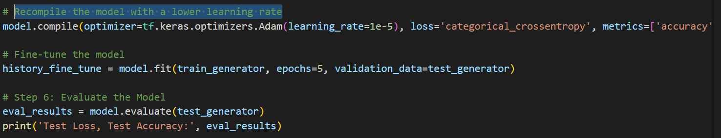

**Step-7: Save the model**

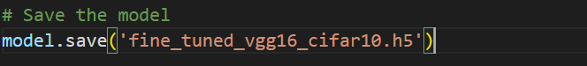

**Outputs:**

* Fine-tuned pre-trained model for a new dataset with training and validation accuracy.

